**CURRICULUM VITAE**

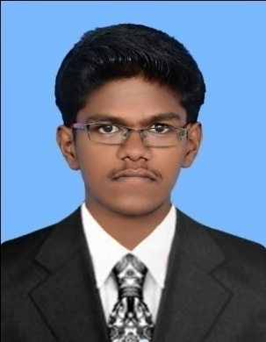

**MANIKANDAN R**

7/1024 Middle Street, Alagankulam,

Ramanathapuram,

Tamil Nadu -623512

India.

Phone: +91 9944268140

E-mail: [manikandan_rv@yahoo.in](mailto:manikandan_rv@yahoo.in)

**Structural Engineer**

Seeking a challenging and rewarding opportunity in design field and to achieve a good recognition so that I can equip myself and be an active participant in a company’s design team.

**ACADEMIC QUALIFICATION**

* **M.E Structural Engineering 2014**

Thiagarajar College of Engineering, Anna University, CGPA 8.46/10

* **B.E Civil Engineering 2012**

Pandian Saraswathi Yadav Engineering College, Anna University, CGPA 7.92/10

**SKILL SET**

STAAD Pro Auto CAD ABAQUS Revit Architecture

MS Office

**AREA OF INTEREST:**

RCC Structures Steel Structures Steel Composite Structures

Prestressed Concrete Structures Design of Bridges Structural Analysis

**ACADEMIC PROJECTS**

**Project:** “Study on Built up Columns from Cold-Formed Steel Angle profiles”

**Review:** This project deals with the behavior study on Battened built up columns from four slender angle sections by using Finite element tool ABAQUS. And also the prediction of ultimate strength from ABAQUS and Different design standards.

**Project:** **“**Artificial aggregate using recycled plastic and brick bats”

**Review:** This project comprised the preparation of artificial aggregate by applying certain manufacturing process on mixed LDPE plastic and Brickbats. The mechanical properties of artificial aggregate were tested. From the tests results, artificial aggregate is suitable for the ordinary concrete.

**CO CURRICULAR ACTIVITIES:**

* Won **First Prize** in **Pro War** competition held at college in 2009.
* Presented seminar on **Offshore Structures** held at college in 2013.
* Presented papers on **Cold Formed Steel Structures** at various colleges in 2014.

**PERSONAL PROFILE**

Date of Birth: 21-MAY-1991

Gender: Male

Father’s name: Ramamoorthy N

Nationality: Indian

Languages Known: English, Tamil

**DECLARATION**

I hereby declare that the above furnished information is true, correct and complete to the best of my knowledge. I assure that I will be successful professional in your concern, by fulfilling my responsibilities.

**Place:** Ramanathapuram Signature

**Manikandan R**